

**HYBRID APPLICATION FOR AUTO MOBILE MANAGEMENT**

**MINI PROJECT REPORT**

***Submitted by***

## Y.Rosi Reddy (111420104104)

## M Imran (111420104057)

***in partial fulfilment for the award of the degree of***

## BACHELOR OF ENGINEERING

***in***

## COMPUTER SCIENCE AND ENGINEERING PRATHYUSHA ENGINEERING COLLEGE

**THIRUVALLUR - 602 025**

## ANNA UNIVERSITY :: CHENNAI 600 025

## BONAFIDE CERTIFICATE

Certified that this project report “**HYBRID APPLICATION FOR AUTO MOBILE MANAGEMENT**” is the bonafide work of the “**Y.Rosi Reddy** **(111420104104)**,**M Imran (111420104057)**” who carried out the project work under my supervision.

|  |  |
| --- | --- |
| **SIGNATURE** | **SIGNATURE** |
| **Dr. THAMBA MESHACH W,** | **Dr.GOPIKRISHNAN.M,** |
| **ASSOCIATE PROFESSOR,** | **PROFESSOR,** |
| **HEAD OF THE DEPARTMENT,** | **SUPERVISOR,** |
| Department of CSE, | Department of CSE, |
| Prathyusha Engineering college, | Prathyusha Engineering college, |
| Thiruvallur- 602 025. | Thiruvallur- 602 025. |

**Place:** Thiruvallur

## Date:

Submitted for the Project Viva-Voce held on at

Prathyusha Engineering College, Thiruvallur- 602 025.

## INTERNAL EXAMINER EXTERNAL EXAMINER

**ACKNOWLEDGEMENT**

Our sincere thanks to **Shri. P. RAJARAO**, Chairman, Prathyusha Engineering College for facilitating us to do this project.

We are greatful to our CEO, **Smt.P.PRATHYUSHA**, for being a source of inspiration.

We are sincerely thanking **Dr.P.M.BEULAH DEVAMALAR**, Director [A&D] for inspiring us.

We would like to express heartfelt gratitude to **Dr.B.R.RAMESH BAPU**, Principal of prathyusha engineering college , for supporting our efforts on this initiative.

We are sincerely thanking **Dr.W.THAMBA MESHACH**, Associative Professor, Head of the Department, for supporting us in all stages of project conduction.

We are grateful to our project coordinator **Mrs.R.MEENA**, Associative professor for her valuable suggestions and guidance.

We thank **Dr. Gopikrishnan M**, Professor and our internal guide, for for her insightful recommendations and direction in making this initiative a success.

We wish to express our sincere gratitude to **PARENTS AND FRIENDS** for valuable help, co-operation and encouragement during this project work.

Last but not least, we wish to express our sincere thanks to the entire teaching and non teaching staff for their support.

**TABLE OF CONTENTS**

**Chapter Contents Page No**

Abstract 5

1 Introduction 6

2 System Study 14

2.1 Drawbacks 14

2.2 Proposed System 15

3 System Design and development 17

3.1 File design 17

3.2 Input Design 18

3.3 Output Design 18

4 System Testing and Implementation 27

4.1 System Testing 27

4.2 System Implementation 32

5 Conclusion 34

6 Scope For Further Enhancement 36

7 Sample Output 38

7.1 Code 42

**ABSTRACT**

In a very user-friendly pattern so that company and customers can navigate easily throughout the site, here we have a dynamic user interface where you can find out your need easily, every section is developed according to buying, renting and selling of automobiles. We provide a vehicle comparison system so that you get the best vehicle in your budget which will contain all your needs in an automotive you would like to have, also the system provides with the comparison of vehicles of different or same brands. Through the use of the automotive site, vehicles are only allocated when need arise and requested. The requests have to b This system has the capability of booking, Renting, and Selling the vehicle. The system is developed e approved by the admin panel and the company panel administrators for the vehicle to be given out. The vehicle is delivered to the customer only if it is not on maintenance, break down, appropriate document verification and is readily available for delivery. The system admin is able to perform the Read, Update, Delete and Edit Operations on Users, Company Departments and Vehicles it also have rights to approve/decline requests from users depending on the status of the vehicle or nature of the procedure included in users of automotive system are able to login with the specified credentials and request the vehicle from the system. The only entry by the user is through unique id number, pass-key else the users cannot access the profile. The system has been designed on the client-server paradigm having HTML, CSS and JavaScript on the front-end and MySQL on the back

**CHAPTER 1**

**INTRODUCTION**

**INTRODUCTION**

**1.1 OVERVIEW OF THE PROJECT**

The proposed project is developed to manage the automobile in the automobile dealer company. The main module in this project is login, automobile management, customer management, sales, complaints and reports. The first module is the login. The automobile showroom owner should login to the project for usage. The username and password are verified and if it is correct, next form opens. If the username and password are not correct, it shows the error message .When a customer search for a automobile, if the automobile is available, they will be taken to a page that shows the details of the automobile including automobile name automobile ID, quantity, price etc. “Automobile Management System” is useful for maintaining automobiles, customers effectively and hence helps for establishing good relation between customer and automobile organization. It contains various customized modules for effectively maintaining automobiles and stock information accurately and safely. When the automobile is sold to the customer, stock will be reduced automatically .When a new purchase is made, stock will be increased automatically. While selecting automobiles for sale, the proposed software will automatically check for total number ofavailable stock of that particular item, if the total stock of that particular item is less than 5,software will notify the user to purchase the particular item. Also when the user tries to sale items which are not in stock, the system will promptthe user that the stock is not enough. Customers of this system can search for a automobile; can purchase a automobile easily by selecting fast. On the other hand the stock ofautomobiles can be maintained perfectly by the automobile shop manager overcoming thedrawbacks of existing system. 1

**1.2 DESCRIPTION OF MODULES**

Major modules of the automobile management system are

• Login module

• Registration module

• Customer module

• Automobile module

• Sales module

• Delivery module

• Supplier module

• Reports module

Login Module

It is used for logging in the automobile showroom management. It is used forverifying the user. Once the user is authenticated, they can access the system.Registration ModuleNew user can register in order to use the full features of this system. Normal users canalso access the proposed system but with limited features. Only the registered users can getmore priorities than the unregistered guest user. Once the guest users register to this system,they can also get full access to this system.ModuleIt is used for adding new customers and for updating existing customers. It is used for details. The module is very

useful to find the number of customers who paid bill. Some customers might not pay the bilon time. Customer details can be easily searched, so it will be easy to find bill payment details.It has a primary key field named customerno. The file is very useful for maintainingcustomers.

**Automobile Module**

It is used for adding new automobiles and for viewing, editing and deleting existingautomobiles. It is used for searching items in this system. Here the admin have the privilegesto search items in this system. Automobile details are stored with their brand name. When aparticular brand is being liked by people, that particular brand will be purchased and kept in stock with large quantity.Sales ModuleIt is used for adding sales details to proposed system. Here the admin have privilegesto add details in automobile showroom management. Sales reports can be viewed overall aswell as date wise, month wise and year wise.

**Delivery Module**

It is used for storing details of new deliveries in the automobile showroommanagement. Admin can perform operations like monitoring automobile stock details,customer order details and delivery details. Delivery reports can be viewed overall as well asdate wise, month wise and year wise.Supplier ModuleIt is used for maintaining supplier details like supplier ID, name, contact person andaddress and phone number. Supplier or dealer can be cancelled when their items are not bein sold out. It is very essential in order to get good stock items for a company.

**1.3 SYSTEM SPECIFICATION**

**1.3.1 HARDWARE SPECIFICATION**

CPU : Intel Core i3

RAM : 32MB

Hard Disk : 5 GB

Monitor : 16 LG

Mouse : Logitech mouse

Keyboard : 104 Keys

Mother Board : Intel

Speed : 3.3 GHZ

**1.3.2 SOFTWARE SPECIFICATION**

Operating System : Windows 2007

Front End : Visual Basic

Back End : MS Access

Reports : Data Report

**1.4 SOFTWARE FEATURES**

VISUAL BASIC 6.0

Visual basic is an ideal programming language for developing sophisticated professional applications for Microsoft Windows. Visual basic programming introduces avariety of features that make it easier to create powerful, flexible applications. It makes use of Graphical User Interface for creating robust and powerful applications. The Graphical user Interface uses illustration for text, which enables users to interact with an application.Visual basic has evolved from the original BASIC language and now contains several hundred statements, functions, and keywords, many of which relate directly to the Windows Operating System includes,

• Multitasking

• Message driven architecture

• Dynamic linking

• CPU time slicing

**Features of visual basic**

• Easier comprehension

• User-friendliness

• Faster application development

• Introduction to Active-X technology

• Internet features

• Support OLE, which is a means of communication and gives application thepower to directly use and manipulate other windows application.

• Data Environment Designer, which provides an interactive design timeenvironment for creating programs with runtime access to data.Integrated Development EnvironmentIntegrated Development Environment (IDE) is a term commonly used in theprogramming world to describe the interface and environment that is used to createapplications. program. IDE is madeup of components such as menu bar, tool bar, object browser, form layout window, and formdesigner.In visual basic 6.0 IDE is a Multiple Document Interface (MDI) format. In Multiple Document Interface format, the windows associated with the project will stay within a singlecontainer known as the parent. Code and form based windows will stay within the maincontainer form.

Visual basic can be used to create the following types of applications.

• Standard EXE

• Active EXE

• ActiveX DLL

• ActiveX Control

• VB application wizard

**Event driven programming**

Visual basic allows adopting more of a parallel approach, with independent sectionsof code for each option that the user may select. This is known as Event DrivenProgramming. Event Driven Programming is based on the Message Driven Architecture ofwindows. Visual Basic programs are built around events. Events are various things that canhappen in program. In Event Driven application, the program statements are executed onlywhen a particular event calls specific parts of the code that is assigned to the event.For example consider textbox control and some of its events,

• Click event fires when text box control is clicked.

• Mouse move event is fired when mouse is moved over the text box.Data access optionsMicrosoft visual data tools allow the ability to view and manipulate tables, views,stored procedures, and database schemas on SQL server and Oracle systems. Visual Basi provides a variety of options to access Remote Client/Server databases.

ADO Object Model

Visual Basic supports ActiveX Data Objects Microsoft’s new, high level interface to all kinds of data. ADO objects can be created at design- time using the updated Data Environment Designer. ADO is an interface for both local and remote data access, remote and disconnected record sets and hierarchical record sets. The ADO object model provides an

easy-to-use set of objects, properties, and methods for creating script that access data in databases.

ADO consists of seven objects, three of which are independent and four are dependent objects. Independent objects can exist by themselves; dependent objects must exist in connection with an independent object.

• Parameter

• Connection

• Command

• Record set

• Error

• Property

• Field

**Basic Purpose of choosing Visual**

• It is an ideal programming language for developing sophisticated professional application for Windows.

• It makes use of Graphical User Interface for creating robust and powerful applications.

• Major features are easier comprehension, faster application development and otheraspects such as ActiveX, Internet features and VB script.

**MS-ACCESS**

Microsoft Access is a powerful database management system and the user can createentire application that requires little or no programming. It supports GUI features and anentire programming language, VBA (Visual Basic 6.0 for application). Access is easy enoughto use that in a short time beginners can manage their own data. In MS –Access, the databasemeans a collection of tables that hold data. It collectively stores all other object such asdatabase management function effectively. The MS-Access database can act as a back-end database for Visual Basic 6.0 asaffront end tool. MA Access supports the user with its powerful management functions.Beginners can create their own database very simply with some mouse clicks. MS-Accessdatabase supports so many data types when a user can incorporate data from otherapplications. A single table can have any number ofindexed fields that can be used to locate records using an expression. This helps in filteringout information according to specific criteria. A user can move inside a table very easily usingthe navigator tools supported by the MS-Access database. A table can be accessed in a number of ways like as a snapshot, dynast, etc.

**CHAPTER 2**

**SYSTEM STUDY**

**2. SYSTEM STUDY**

**2.1 EXISTING SYSTEM**

All automobile details like available in the company are entered and managed in thiand managed. Price details and stock details of the automobiles are managed separately. The customer details are entered to call the customer for further purchase of automobile. The 8 customer name, address and phone number details are managed separately. The details are entered and edited by the administrator. But everything is done manually. Most of the existing system is manual, so datamanipulations are not accurate and also processing time is slow. When the stock andautomobile count increases, manual manipulation of data becomes very difficult.

**2.1.1 DRAWBACKS**

Even though computerized system exists, there are various drawbacks. They are as

follows.

• User cannot search automobiles fast when the number of automobiles increases.

• Primary key fields should be used wherever necessary while designing in order tomanage database efficiently and for accessing information soon.

• Stock management is not efficiently done. User can only know when the stock is empty.

• Takes much time for searching particular automobile details.

• Difficult to maintain automobile details and employee details

• Existing system is not accurate.

• Even though some existing systems are computerized, there occur redundancy problems due to duplication of entries.

• If the automobile entries have duplicate values, it cannot be maintained properly and accurately

**2.2 PROPOSED SYSTEM**

The proposed system is very useful for the employee and customers. It avoids theoverheads for the employee. They can minimize the working stress and can keep essentialdocuments related to the automobile and the passengers as a softcopy. The advantage of theproposed system is the reduction in the cost of the office equipments and the transaction isdone quickly. Any employee can answer if any delivery for a particular customer in aparticular day is available or not.

The proposed project will allow the customers to perform certain activities like loginand searching for automobiles. Customers may open an account with the store if they wish authenticated and it is alsopossible to find whether they are customer or admin through their login information which

**2.2.1 ADVANTAGES OF PROPOSED SYSTEM**

• Stock management as well as automobile management is done very quickly as well as efficiently in proposed project.

• Another feature added in the project is, when the regular customers purchase items from automobile, software will automatically give them discount offers.

• Prepares and produces accurate outputs

• Reduces the time needed and expenses

• Makes the information flow efficient

• Easy report generation is possible

• Provides attractive user interface.

• Efficient searching of automobile details by just entering automobile code is possible.

**CHAPTER 3**

**SYSTEM DESIGN AND DEVELOPMENT**

**3. SYSTEM DESIGN AND DEVELOPMENT**

**3.1 FILE DESIGN**

Flat File Database A flat file database is a database designed around a single table. The flat file designall database information in one table, or list, with fields to represent all parameters. A flatfile may contain many fields, often, with duplicate data that are prone to data corruption. data between two flat files have to be merged, it is needed to copy and PSMte relevantnformation from one file to the other. There is no automation between flat files. If two or more flat files that contain client addresses, it is required to manually modify the address parameters in each file that contains that client’s information. Changinginformation in one file has no bearing on other files. Flat files offer the functionality to store information, manipulate fields, print or display formatted information and exchangeinformation with others, through email and over the Internet. Some flat files may be attachedto external files, such as text editors, to extend functionality and manage related information.

A relational database, on the other hand, incorporates multiple tables with methods forthe tables to work together. The relationships between table data can be collated, merged anddisplayed in database forms. Most relational databases offer functionality to share data:

• Across networks

• Over the Internet

• With laptops and other electronic devices, such as palm pilots

• With other software systems

Designing flat file databases is simple and requires little design knowledge. Flat filesan be developed using just about any database engine. Flat files can be created in relational database engines by not taking advantage of relational design concepts. Designing a\relational database takes more planning than flat file databases. With flat files, it is possible to add it is required to be careful to store data in tables such that

**3.2 INPUT DESIGN**

Input is any data or instructions entered into the memory of a computer. Two types ofinput are data and instructions. Data is a collection of unorganized items that can includewords, numbers, pictures, sounds, and video. A computer processes data into information,which is organized, meaningful, and useful. Instructions can be in the form programs,commands, or user responses

**3.3 OUTPUT DEGIN**

Output design involves specifying how production of on-screen reports and paper based reports will occur. Output may occur to database or file for storing information enteredor also for use by other systems. Output is data that has been processed into a useful formcalled information. Four types of output are text, graphics, audio, and video. Text consists of

characters (letters, numbers, punctuation marks, or any other symbol requiring one byte ofcomputer storage space) that are used to create words, sentences, and paragraphs. Graphics are digital representations of non-text information such as drawings, charts,photographs, and animation (a series of still conveying information to a user.

**3.4 DATABASE DESIGN**

Database is designed to manage large bodies of information. The management of data involves both the definitions of structures for the storage of information. In addition the data base system must provide for the safety of the information solved, despite system crashes ordue to attempts at unauthorized access. For developing an efficient databaseprojecthave to fulfill certain conditions such as controlled redundancy.

• Defining the data

• Inputting the data

• Locating the data

• Accessing the data

• Communicating the data

• Revising the data

Objectives of Database design

In database design several objectives are designed such as:

• Ease of use

• Control of data integrity

• Control of redundancy

• Control of security

• Data independence (logical & physical)

• Data storage protection

• System performance

**3.4.1 DATAFLOW DIAGRAM**

A Data Flow Diagram (DFD) is a diagram that describes the flow of data and theprocesses that change data throughout a system. It’s a structured analysis and design tool thatcan be used for flowcharting in place of or in association with information. Oriented andoriented system flowcharts. Four basic symbols are used to construct data flowdiagrams. They are symbols that represent data source, data flows, and data transformationsand data storage. The points at which data are transformed are represented by enclosedfigures, usually circles, which are called nodes.

Data Flow Diagram Symbols

- Source or Destination of data

- Data flow

-Process

-Storage -Storage

When analysts prepare the Data Flow Diagram, they specify the user needs at a level detail that virtually determines the information flow into and out of the system and therequired data resources. The network is constructed by using a set of symbols that do not imply physicalimplementations. The Data Flow Diagram reviews the current physical system, prepares inputand output specification, and specifies the implementation plan.Steps to Construct Data Flow DiagramsFour steps are commonly used to construct a DFD

**Rules for constructing a Data Flow Diagram**

• Arrows should not cross each other.

• Squares, circles and files must bear names.

• Decomposed data flow squares and circles can have same names.

• Draw all data flow around the outside of the diagram.

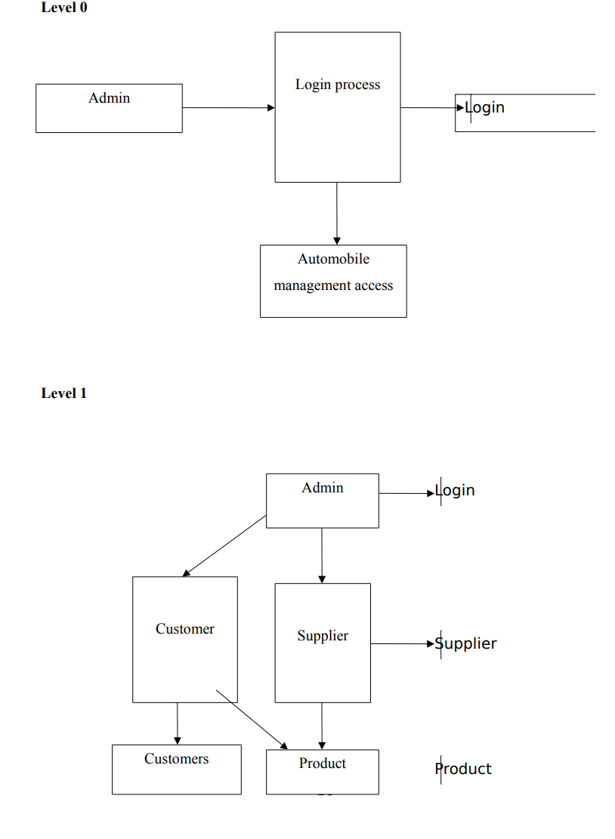

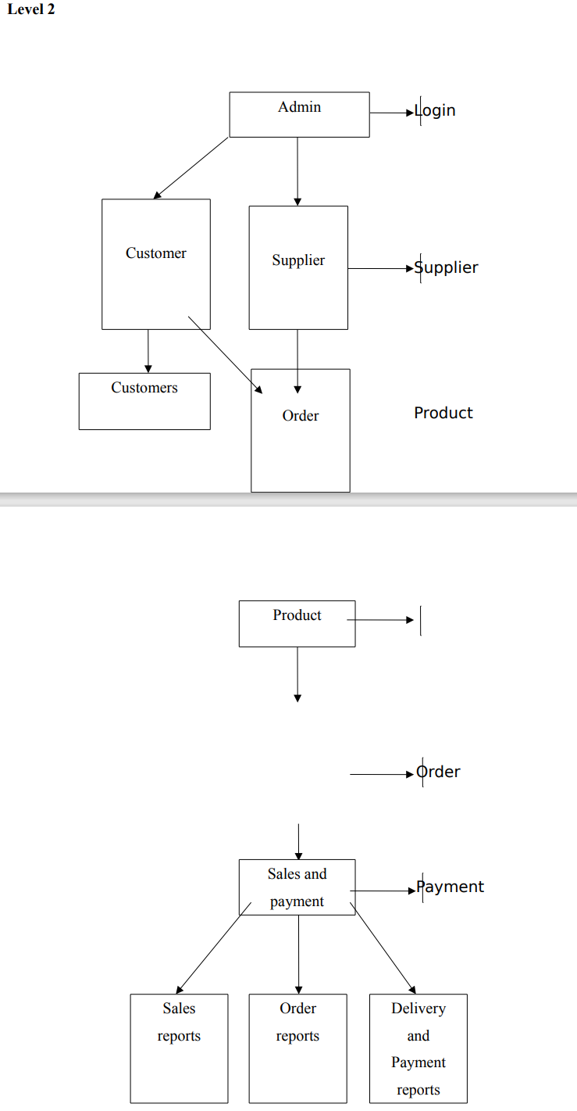

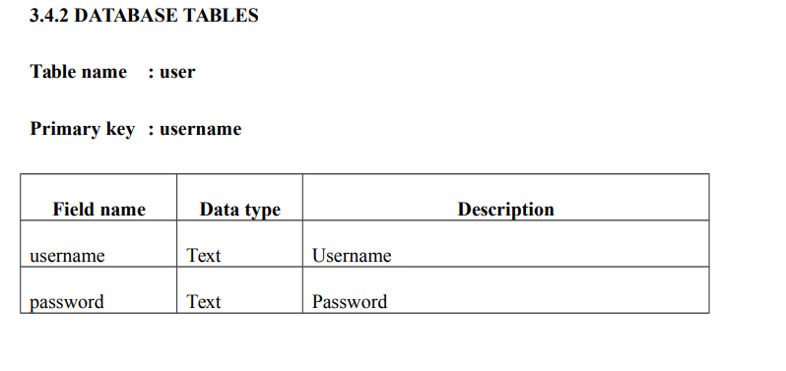

Table name :cust_info

Primary Key : cid

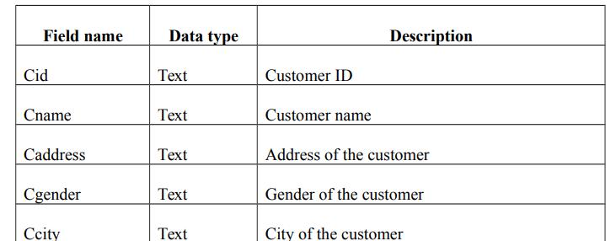

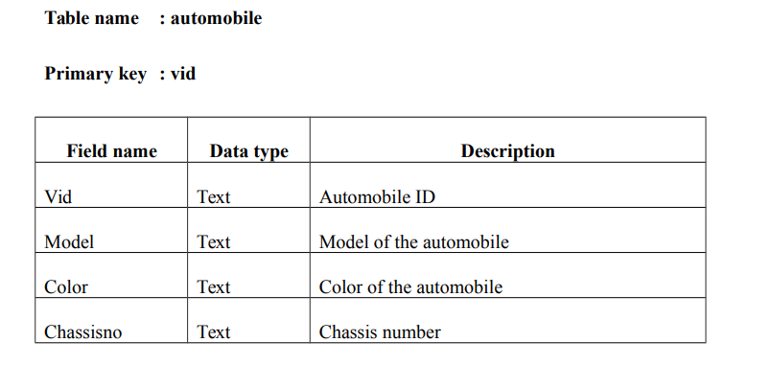

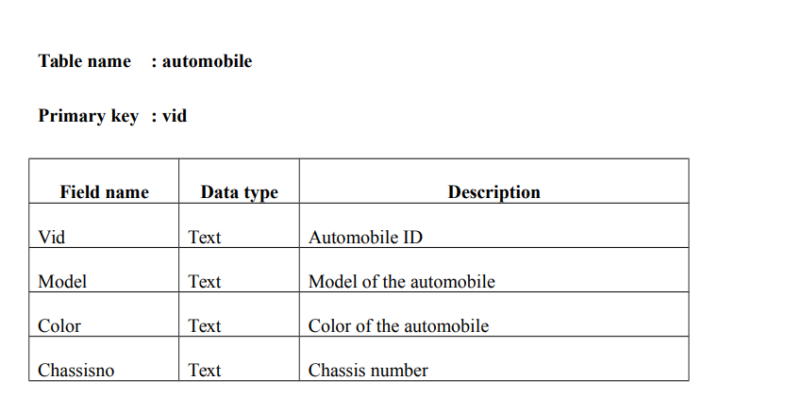

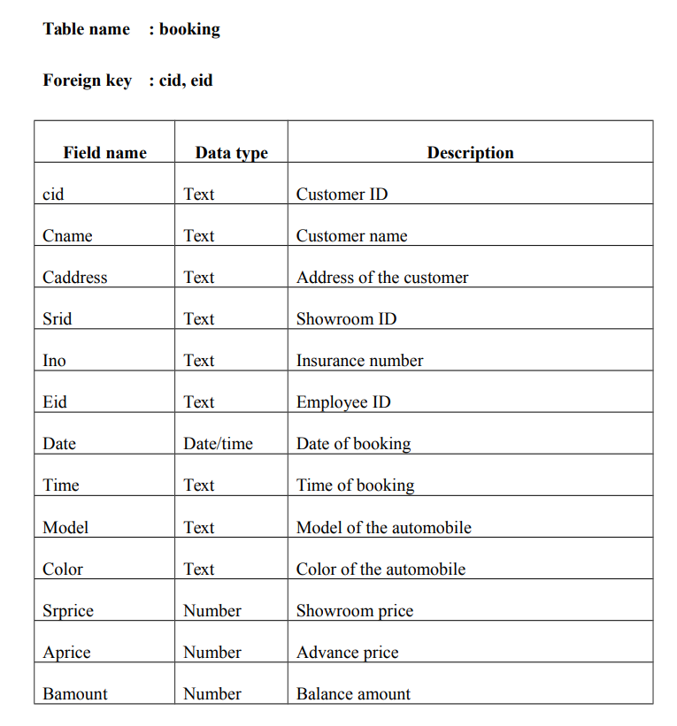

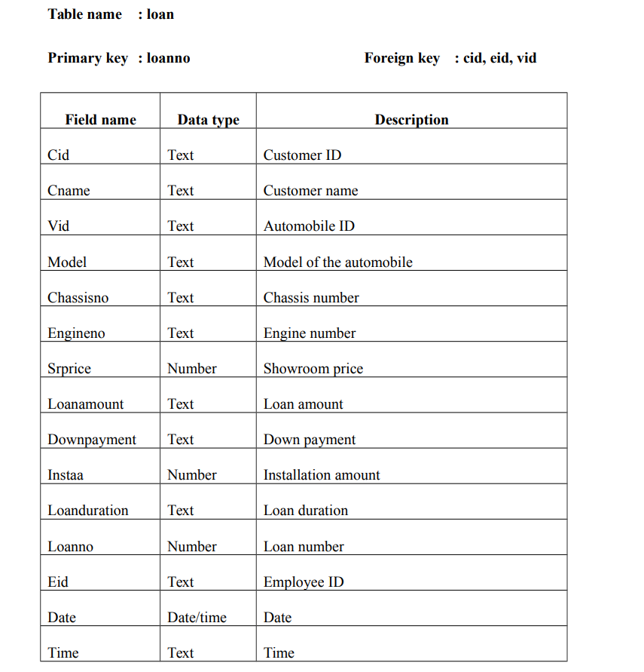

**CHAPTER 4**

**SYSTEM TESTING AND IMPLEMENTATION**

**4. SYSTEM TESTING AND IMPLEMENTATION**

**4.1 SYSTEM TESTING**

The common view of testing held by users is that it is performed to prove that there are no errors in a program. It is extremely difficult since designer cannot prove to be one hundred percent accurate. Therefore, the most useful and practical approach is with the understanding that testing is the process of executing a program with explicit intention of finding errors that make the program fail. Testing has its own cycle. The testing process begins with the product requirements phase and from there parallels the entire development process. In other words, for each phase of the development process there is an important testing activity. Successful testing requires approach. It requires focusing on basic critical factors:

• Planning

• Project and process control

• Risk management

• Inspections

• Measurement tools

• Organization and professionalism

**Test Plan**

Before going for testing, first we have to decide upon the type of testing to be carried out. The following factors are taken into consideration:

• To ensure that information properly flows into and out of program

• To find out whether the local data structures maintains its integrity during all steps

in an algorithm execution

• To ensure that the module operate properly at boundaries established to limit or

restrict processing

• To find out whether error - handling paths are working correctly or not

• To find out whether the values are correctly updated or not

• Check for validations

**Black Box Testing**

It is a software testing approach in which the tester doesn’t know the internal working of the item being tested. For example in a Black box test, on software design the tester only knows the input and the expected outputs. Tester doesn’t know how the program derives the output. Tester doesn’t even imagine as to how, the coding is done. Tester need to know only the specifications.

The advantages of black box testing approach are

• The test is unbiased because the designer and the tester is independent of each

other

• The tester needs no specific knowledge on any programming language

• The test is done from the point of view of the user, not the designer.

• The test can be designed as soon as the specifications are complete

The disadvantages of black box testing approach are

• The test can be redundant if the software designer has already run a test case.

• The test can be difficult to design

• Testing every possible input stream is unrealistic.

**Unit Testing**

Unit or module testing is the process of testing the individual components(subprograms or procedures) of a program. The purpose is to discover discrepancies between the modules interface specification and its actual . In our system each module must be tested independently for validation. Integration testing is the process of combining and testing multiple components together. The primary objective of integration testing is to discover errors in the interfaces between the components. In our system each of the modules mentioned above, are tested for checking the integration between them, after each of them are tested individually. System Maintenance All system is dynamic and subjects to constantly changing requirements. Effort must be devoted to adapting them and design must be flexible specified so that such changes can be easily implemented. It activity is called system maintains. It includes improvement of system functions and correction of errors. Back up of the entire database files are taken and stored in secondary storage devices like magnetic tapes and disks so that it is possible to restore the system at the earliest. If there is a break down or collapse, then the system giver provision to restore database files, storing data in a separate secondary device leads to an effective and efficient maintains of the system. The master file has flags for maintains after for maintains. After the mentioned period, the rejection suppliers, unused data in the files will be deleted in the master file. It method is the increasing the memory to store the data. Software maintenance is a set of software engineering activities that occur after software has been delivered for the customer and put into operation. The success of the software and the project relies on the maintenance procedure adopted. As with the venture of human, not a single one is perfect. The further modifications are left to the followers. It is because the opinion or vision or a thing differs from individual to individual. The maintenance is performed at regular intervals to keep the project safe and reliable.

**System Analysis**

The term system is derived from the Greek word ‘systema’, which means of organized relationship among functioning units of components. And the study of system concepts has three basic implications:

• A system must be designed to achieve a predetermined objective

• Interrelationships and interdependence must exist among the components

• The objectives of the organizations as a whole have a high priority than the

objective of its subsystems.

**Preliminary Analysis**

Analysis is the detailed study of the various operations performed by a system and their relationships within and outside the system. For the efficient and effective utilization of the available resources, timing availability of accurate information is very important. Information is the back bone of any organization. There for, it has to be made available all time to ensure proper decision-making. Information also has to be accurate, current, timely, relevant and usable. In other words, an effective information system should be able to provide information to those in need of it, at the time they need of it, at the time they need it and in the way they need it. The need

**Threats to System Security**

The lists of potential threats are as follows

• Errors and Omissions

• Disgruntled and Dishonest Employees

• Fire

• Natural Disaster

• External Attack

**System Security**

Security is a critical stage in system development. Even candidate system must provide built-in features for security and integrity of data. Without safe guards against unauthorized access, fraud, embezzlement, fire and natural disaster, a system could be so vulnerable as to threaten the survival of the organizations. To do an adequate job on security, the risk, exposure, cost and specific measures such as password should be to provide protection. In addition, back up of copies of software and recovery restart procedures must be available when needed. The amount of protection depends on the sensitivity of data, the reliability of the userand the complexity of the system. The motive behind security is to keep the organization running, protect data as an asset and seek management support for more installations.

**System Security Measures**

After system security risk has been evaluated, the next step is to select security

measures. The measures are

• Identification

• Access Control

• Audit Control

• System Integrity

Identification

It is the scheme of identifying person to the system based on “Something you know” such as a password or a picture badge, “Something you are” such as finger print or voice print or “Something you have” such as credit card, key or special terminal.

**Access Control**

Controlling the access to the computer facility is secured through encoded cards or similar devices. Encryption prevents intruders from accessing data by scrambling messages across telephones to the destination.

**Audit Control**

Auditing must be supported at all levels of management. Audit control protects a system from external security breaches and internal fraud or embezzlement. Various software Automobile management access

**Audit Control**

Auditing must be supported at all levels of management. Audit control protects a system from external security breaches and internal fraud or embezzlement. Various software programs are available to help in audit function.

**System Integrity**

back of hardware and software are extremely important. The line of different safeguards the functioning of hardware, software and physical security and operating procedure. Proper

**4.2 SYSTEM IMPLEMENTATION**

System implementation is the important stage of project when the theoretical design is tunes into practical system. The main stages in the implementation are as follows:

• Planning

• Training

• System testing and

• Changeover planning

Planning is the first task in the system implementation. Planning is deciding on the method and the time scale to be adapted. At the time of implementation of any system people from different departments and system analysis involve. They are confirmed to practical problem of controlling various activities of people outside their own data processing departments. The line manager controlled through an implementation co-ordinate committee. The committee consists of ideas, Problems and complaints of user department. It must also consider,

• The implementation of system environment.

• Self selection and allocation for implementation tasks.

• Consultation with unions and resources available.

• Standby facilities and channels of communication.

**CHAPTER 5**

**CONCLUSION**

**5. CONCLUSION**

The system is completely menu driven and extremely user friendly since it is developed in an efficient front end tool VB. Appropriate error messages are also provided too guide the user in a proper and user friendly manner. The software “Automobile Management System” has been developed in windows 2007 environment using PHP as front end and MS Access as back end. Time consumptions reduced to a great extent and user as less complexity in handling it database. The project is fully fledged and user friendly, End users will be lightened in using it software because it is easy to have bills and reports and mostly all contents to be entered are to selected from combo box. It reduces the calculating efforts to be carried out by the staff.

**CHAPTER 6**

**SCOPE AND FUTURE ENHANCEMENT**

**6. SCOPE FOR FURTHER ENHANCEMENT**

Further expansion of the system also can be done in future if needed. The application can be enhanced in the future with the needs of the organization. The database and the information can be updated to the latest forthcoming versions. There are also possibilities for enhancing and further developing the project with customized reports according to the latest information and needs of the company. Thus the system can be altered in accordance with the future requirements and advancements. System performance evaluation must be monitored not only to determine whether or not they perform as plan but also to determine if they should have to meet changes in the information needed for the company. The performance of the system will be evaluated to determine whether system achieves the results that are expected and whether the predicted benefits of the system are realized.

**CHAPTER 7**

**APPENDIX**

**A.SAMPLE OUTPUT**

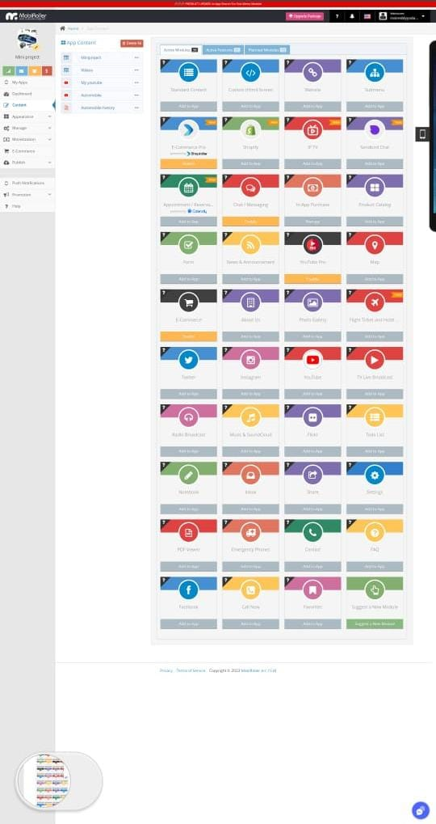

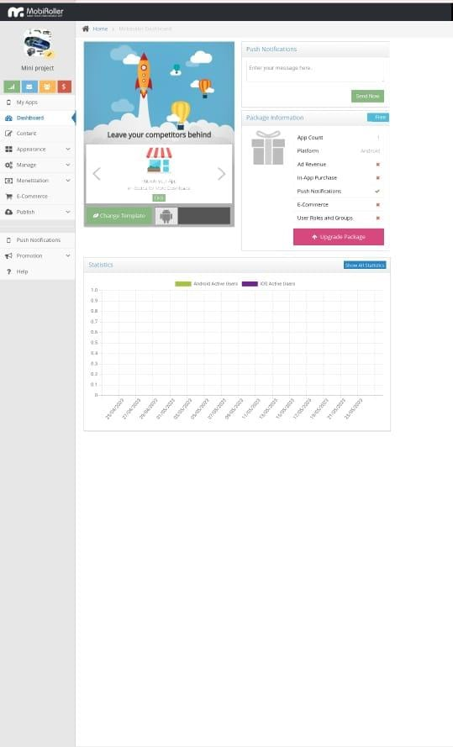

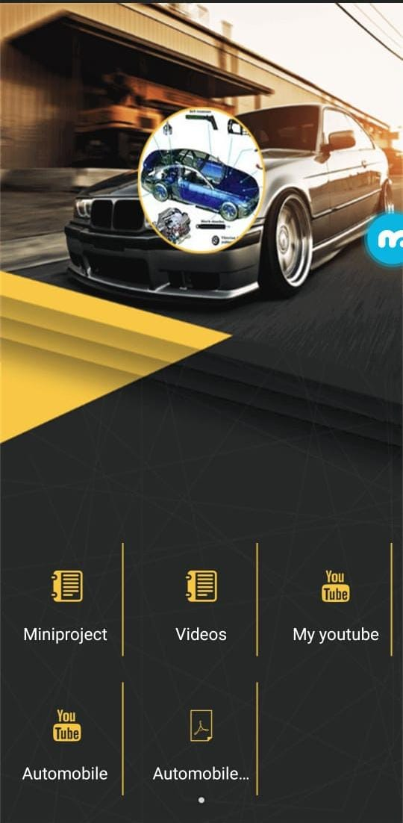

**7.1 CODE :**

// HTML markup

<select id="vehicleSelect">

<option value="">Select a vehicle</option>

<option value="car">Car</option>

<option value="motorcycle">Motorcycle</option>

<option value="truck">Truck</option>

</select>

<div id="vehicleDetails"></div>

// JavaScript code

document.getElementById('vehicleSelect').addEventListener('change', function() {

var selectedVehicle = this.value;

var vehicleDetails = document.getElementById('vehicleDetails');

if (selectedVehicle === 'car') {

vehicleDetails.innerHTML = '<h2>Car Details</h2>' +

'<p>Make: Honda</p>' +

'<p>Model: Civic</p>' +

'<p>Year: 2022</p>';

} else if (selectedVehicle === 'motorcycle') {

vehicleDetails.innerHTML = '<h2>Motorcycle Details</h2>' +

'<p>Make: Yamaha</p>' +

'<p>Model: R6</p>' +

'<p>Year: 2021</p>';

} else if (selectedVehicle === 'truck') {

vehicleDetails.innerHTML = '<h2>Truck Details</h2>' +

'<p>Make: Ford</p>' +

'<p>Model: F-150</p>' +

'<p>Year: 2020</p>';

} else {

vehicleDetails.innerHTML = '';

}

});

**REFERENCE BOOKS**

• James. A Senn, ‘System Analysis and Design’, 2005.

• Pressman, ‘Software Engineering’, 2010, pp.200-230.

• Elias Award, ‘System Analysis and Design’, 2006.

• S.S. Ipress, ‘VB, 2006, pp.1-180.

• S. Parthasarathy, B. W. Khalakar, ‘System Analysis, Design and Introduction toSoftware Engineering’, 2010, pp.39-80.

**REFERENCE WEBSITES**

• www.programmingworld.com

• www.vbnetcode.com

• www.w3schools.com

• www.vbcode.com

• www.vbdevelopplus.com

• www.codepark.com